#### Traverse White .eps

## VacciNation: Exploring vaccine confidence with people from African, Bangladeshi, Caribbean and Pakistani backgrounds living in England.

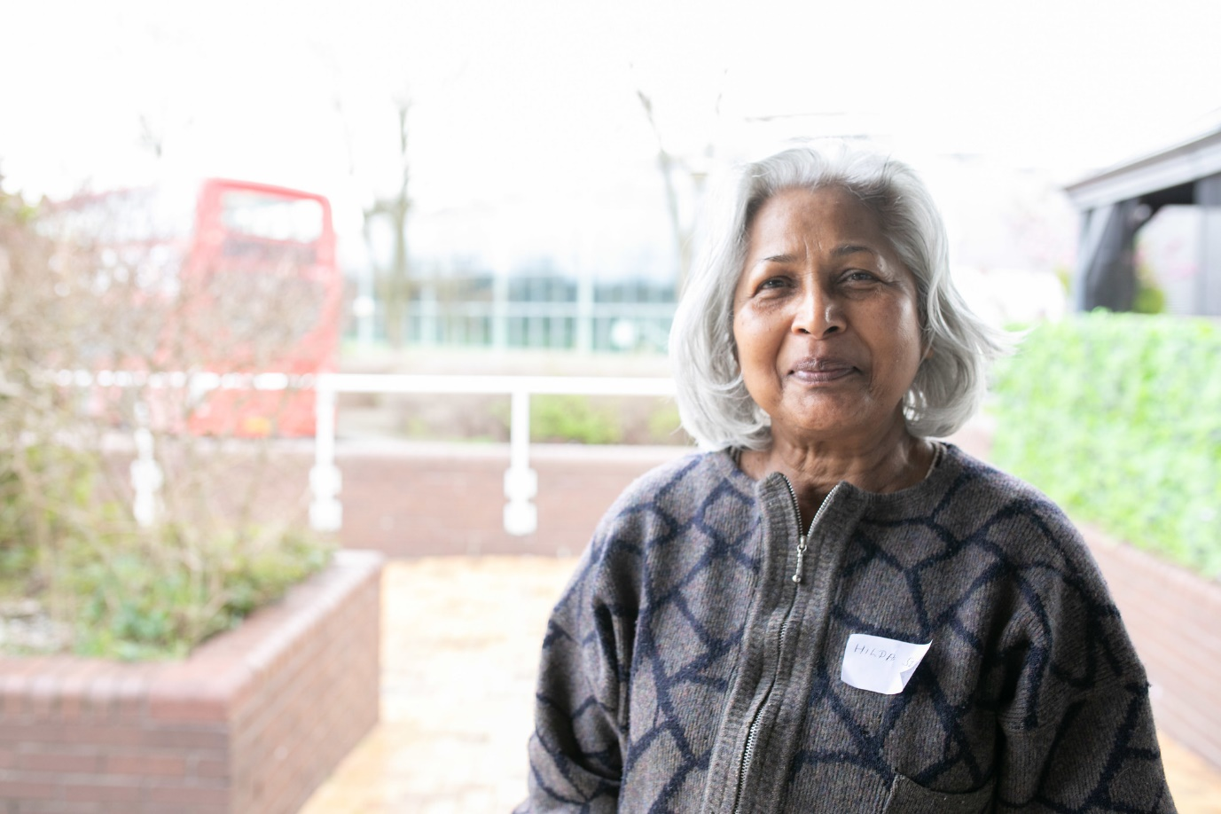

**Insight report**

**June 2021**

#### Contents

|  |  |
| --- | --- |
| Executive summary | 3 |
| Why do this research? | 8 |
| Approach | 13 |
| Who took part? | 18 |
| Findings | 20 |
| Key action points and top tips | 53 |

#### Executive summary

Since January, the Healthwatch network has gathered views and experiences from 15,000 people across England about the Covid-19 vaccine and the roll out.

Overall, feedback has been positive but uptake is still significantly lower among specific communities, and there remain issues of vaccine confidence among groups now being targeted for the vaccine.

Healthwatch England commissioned Traverse to undertake in-depth conversations and online exercises with 95 participants from African, Bangladeshi, Caribbean, and Pakistani ethnicity over a period of five weeks during March and April.

The engagement and research were with people who have primarily hesitant attitudes or lack confidence in the vaccines, testing out a number of hypotheses as to why people are hesitant and what could be done to give additional assurance.

It is clear from this work that attitudes to the vaccine are incredibly personal and it is important not to make broad conclusions about the views of whole communities as a result of these findings. We have therefore taken great care, and with some caution, pulled out some themes from this complex piece of research to help the Department for Health and Social Care, NHS England and Improvement and others to take action.

It is also worth noting that both the findings from this work and the way in which it was undertaken provide important lessons beyond the Covid-19 vaccines programme and can help as we all work together to tackle health inequalities.

**We would like to extend our thanks and appreciation to all those who took part in this research.**

### Individual agency and an ability for a person to act on their own behalf is important in relation to the COVID-19 vaccine.

Participants prefer to be presented with information and make their own decisions from it, rather than being told they must do something as a duty without being provided with all the information. Limiting or removing an individual’s agency from their decision making may result in them looking for alternate information.

### Independence of institutions and those who speak for them.

It is important to view the findings of this research within a wider contextual picture, informed by historic and current experiences of unfair treatment by government agencies, officials, other institutions and pharmaceutical companies. A lack of trust in these organisations and individuals features strongly in our findings. People, largely, trust the NHS. However, they trust it when it is independent of Government. There was general distrust of those who had any possibility of standing to gain commercially from the roll-out.

### Participants associated levels of trust with the level of real-world experience an individual had.

Most notably, people said that they trust frontline healthcare workers to talk about COVID-19 and the vaccine, whereas there is less trust in those very senior in the NHS or Public Health England because they are perceived to have less tangible experience.

### Participants linked the notions of transparency and trust together.

Generally, the more transparent an organisation or information source is, the more people consider it to be trustworthy. Regardless of whether an individual would access information or not, they want to know all the information is public and accessible.

### Targeted messaging can have the opposite to the intended impact.

Participants said they feel like Black and Asian people are being singled out and forced into a decision, leading to suspicion. For example, participants did not like Black and Asian celebrities being shown to speak with authority on vaccines or having targeted campaigns for Ramadan.

### Conscious and unconscious trust needs to be considered.

Despite the fact that people will consciously say they trust doctors, scientists or health care workers, it was clear from our conversations that participants are not always conscious of their circles of trust. Some participants said they would foremost listen to doctors and scientists but if their religious leader did advise against having the vaccine, that would override other sources of information.

## Top tips to provide additional assurance and increase confidence

1. **Localise the approach.**Reach out to communities and engage with people directly.
2. **Deliver messages via people who have a clear connection or lived experience of the vaccine**and where possible a tangible relationship to the individual. E.g. a local healthcare worker.
3. **Clearly communicate why people should have the vaccine.** For example, is it to keep people out of hospital, stop others or themselves from becoming ill, reduce the spread of infection or mutations.
4. **Provide information for unanswered questions.** Unanswered questions from participants can be found in the findings section of the main report.
5. **Provide clear references to source information in any communication** and where to go to find out more so people can fact-check for themselves.
6. **Give people the information they need to make decisions they feel comfortable with.** Face ambiguity head on.
7. **Carefully consider targeted messaging.** Don’t lump people from different ethnic backgrounds into one group.

## A note to the reader

One of the key findings of this research was around the use of inclusive terminology. Participants in this study were from African, Bangladeshi, Caribbean, and Pakistani backgrounds and cautioned against the use initialisms such as BME and BAME. They spoke about the diversity of individual experiences and opinions within Black, Asian and other minoritised groups.

We recognise and respect this finding and throughout the report have strived to hold ourselves accountable to it.

We also acknowledge that there is a live, ongoing debate about terminology with no clear consensus on how best to reflect individual diversity while talking about groups of people. Throughout the research participants also grappled with this and often used existing terminology such as BAME.

Ultimately, and in line with another of the key findings from this report – the importance of acknowledging ambiguity - this slide intends to highlight that we recognise the lack of agreement that exists in the use of language and speak directly to it.

The research team has worked hard to reflect participants’ views and ensure that the language used does their views justice, while accepting that this has been challenging to achieve in places. We hope that overall we have achieved the right balance.

A number of sources of information are referenced throughout this report. These are indicated (n) and full links can be found in a bibliography slide at the end.

#### Why do this research?

## It was important to understand barriers to uptake as the vaccine was rolled out

Healthwatch England, the independent champion for people who use health and social care services, in collaboration with Traverse, an independent research organisation, and the NHS Race and Health Observatory, wanted to provide live insights, as the Covid-19 vaccine roll-out progressed, to better understand current trends in vaccine barriers among Black and Asian people.

The findings from this project will be used to inform Government activities for the vaccine roll-out and therefore timeliness and pace in delivering findings has been important. The research aim was to explore what about the current roll-out strategy wasn't speaking to participants and why.

Despite concerns early on about uptake rates among Black and Asian people there have been positive improvements:

* By mid-April, the numbers of over 60s from Black communities who had been given one dose of the vaccine was at 69% - 26 points lower than the White population but up from 30 points in mid-February.
* Among Asian communities the uptake rate in the over 60s was at 85%.
* Indeed, the rate of growth among Bangladeshi and Pakistani groups has been particularly impressive – rising four/five-fold.

This is likely a result of two things:

* Firstly, many of those with reservations expressed wanting to wait and see before having the vaccine, so time and the numbers of successful vaccines completed have had a positive impact.
* The huge communications efforts the Government and the NHS have gone to.

However, while the current strategy appears to be working well for many, it isn’t working as well for hesitant or less confident individuals. The vaccine roll-out is also now entering a new phase as it reaches into younger populations who may perceive less need to get vaccinated. With this is mind, the project aimed to deepen understanding about what participants felt was lacking in the current roll-out strategy and to use this information to help address existing concerns about having the vaccine.

## Going beyond statistics to uncover reasons behind lack of confidence and hesitancy

While lots of data exists about disparities in vaccine uptake among Black and Asian people, there’s not so much about *why* they exist; this report hopes to begin filling this gap. In early 2021 Healthwatch England (1) conducted a short insight project to better understand potential barriers to vaccine uptake amongst groups which are hesitant or lack confidence, and through this work they developed a number of hypotheses (below). Through this research we aimed to test these hypotheses and to explore them in more depth.

### Practical barriers:

* Lack of proximity to test and vaccine centres (both geographical and cultural) is inconvenient.
* Not having test and vaccine centres being perceived as a physical part of the community (seeing other people successfully take the vaccine can reduce anxiety).

### Transport barriers:

* People who are shielding are averse to travelling because of the risk of transmission– particularly on public transport.
* Private travel such as personal cars or by taxi is a financial barrier for some.

### Fake news/misinformation:

* Sources and content of misinformation are both important factors when weighing-up taking the vaccine.

### Deeper cultural mistrust:

* A variety of factors ranging from religious beliefs to negative historical precedents increases mistrust.

### Impact of health and care staff:

* The imagery of medical staff not taking the vaccine reduces confidence in taking the vaccine.

### Generational differences:

* Younger generations are more hesitant than older generations.

### Community/peer interaction:

* Members of the local community influencing the behaviours and attitudes of others.

### Impact of taking the vaccine

* Some people experience negative reactions (temporarily feeling unwell, for example) and this fact is seemingly being overlooked, which could be impacting on levels of trust.

## An upfront social media scan highlighted two very vocal camps, with little space for uncertainty about the vaccine to be discussed

While conducting a social media scan as a part of the set-up stage of this project (an exercise in reading through social media posts related to the vaccine and ethnic minorities) it became clear that when reservations about the vaccine were expressed online, they were often met with strong reactions. Discussions on social media and comments sections under content about the vaccine had a tendency to quickly become negative. Example social media content can be accessed in the bibliography at (2) (3) and (4).

Beyond the online environment, there has been public disapproval in the media of anyone questioning the decision to have the vaccine, with the sentiment that those who do must be uneducated, selfish or lacking in intelligence.

Meanwhile, those on social media squarely in the camp of not wanting the vaccine are targeting those who speak positively about it as pushing the mainstream agenda, being ‘sheep’, and blindly following instruction from the establishment.

This is problematic as neither ‘side’ appear to see value in the views of the other. If entering into online debate, there appears to be little room to express any level of uncertainty, negativity or positivity, before being labelled as firmly pro or anti the vaccine. With little room for nuance or balance, there is a lack of productive discussion.

One of the intentions of this research was to provide a safe space for these conversations to take place, including those who may be less vocal on social media.

#### Approach

## Partnership

This project was designed and delivered collaboratively by **Healthwatch** **England, Traverse**, and with input from the **NHS Race and Health Observatory.**

Healthwatch England are the independent champion for people who use health and social care services.

Traverse is an independent research and engagement consultancy that works with different organisations and across a variety of sectors to gain insights into complex social and environmental issues. We do this by giving a voice to the people affected by the issue in question. Traverse has extensive experience delivering research and engagement projects in the health and social care space.

The NHS Race and Health Observatory has been established to identify and tackle the specific health challenges facing Black and minority ethnic patients and communities.

## Research methodology

During the design phase, desk research and a social media scan were undertaken. This included reading published literature on the subject of vaccine hesitancy and lack of confidence among different ethnic groups, relevant news articles from a range of newspapers and online sources, following relevant hashtags on Twitter to observe debates, identifying prominent individuals and organisations who have been vocal on the subject, and reading through comments pages on written and video content related to the issues. This practical exercise was designed to be a ‘scan’ in order to gain a snapshot of the issues at a moment in time, with one source leading to another.

An online qualitative research platform was used to host the VacciNation research project. Participants who were recruited and met the screening criteria were invited to register on the platform and create a profile.

The research project ran for five weeks, during which participants were required to complete four activities relating to their attitudes and opinions on the Covid-19 vaccine. The variety of activity types and the flexibility in design options available allowed for the activities to be iteratively designed on a weekly basis. The built-in analysis functionality also allowed the project team to quickly share insights as they emerged while the project was still live.

Traverse also hosted two online discussions with participants during the five weeks in order to explore in more detail the data being shared on the platform.

## Project design

## Activity and question design

The four activities on the engagement platform were designed to allow participants to share their current attitudes towards the Covid-19 vaccine roll-out, as well as the various factors that shaped their beliefs and concerns. Some activities encouraged participants to share multimedia answers, allowing them to upload videos or images to add context to their response. Below is a breakdown of the four activities, with some examples of the questions posed to participants.

|  |  |  |  |
| --- | --- | --- | --- |
|  | **Research questions** | **Response type** | **Research objectives** |
| **Activity 1** | Where do you currently stand on the Covid-19 vaccine? | Multimedia | Establish a baseline of participant attitudes towards the vaccine. |
| What questions do you have about the Covid-19 vaccine? | Open text | Understand what gaps exist in participants’ knowledge about the vaccine. |
| **Activity 2** | What information has influenced your beliefs about the Covid-19 vaccine? | Multimedia | Understand the content, format and source of information participants are receiving about the vaccine. |
| **Activity 3** | How does this messaging about the vaccine make you feel? | Open text | Understand how messages with varying content and format impact participants. |
| Who do you trust to answer your questions about the vaccine? | Fill in the blanks | Understand which institutions participants trust to address concerns. |
| **Activity 4** | What do you think is the reason for the vaccination drive? | Open text | Understand what participants think is the reason behind the vaccine drive. |
| What would you do next if you were responsible for the vaccine-roll-out? | Open text | Understand participant priorities in comparison to the current roll-out. |

#### Who took part?

## Recruitment process

Participation in this project was incentivised. In order to engage with members of the population who do not usually take part in market research, participants were recruited via three different channels:

1. **Professional market recruitment agency.**
2. **Organic recruitment, identifying and approaching existing community groups who helped spread the word. This included sharing information about the project on social media.**
3. **Healthwatch England asked local Healthwatch partners to share details about the project with their networks.**

The recruitment materials used explicitly invited Black and Asian people to take part – see **Appendix B** for an example of recruitment materials.

The break-down of how many participants in total were recruited via each channel is included in this table.

|  |  |
| --- | --- |
| **Recruitment channel** | **Number of participants** |
| Market recruiter | 60 |
| Organic and Healthwatch network | 40 |
| **Total** | **100** |

All prospective participants completed a screening questionnaire in order to express an interest in taking part in the project. The survey helped identify participant demographics as well as their current attitude towards the Covid-19 vaccine. In total 100 participants were invited to register for the platform, and **95 ultimately participated in the online activities.**

## Participant profiles

More women than men took part in the research, and the majority of participants were between the ages of 30 and 49 years-old. It was more challenging to recruit older participants. This is likely to be due to the fact that at the time of recruitment, people over the age of 70 had already been offered the vaccine. This segment of the population is also more at risk of death or becoming seriously ill if they contract Covid-19 and therefore more likely to take the vaccine.

Approximately three quarters of participants were hesitant or lacked confidence in taking the vaccine. The most common sentiment amongst this hesitant group was feeling unsure if they would take the vaccine if offered it at the time of completing the recruitment screener. A minority of participants who are hesitant or lack confidence said they definitely would not take the vaccine. Some participants, despite having taken the vaccine, were still anxious about the potential side effects.

The vast majority (85%) of participants self-identified as religious, with the most common response being Muslim which was followed closely by Christian.

In terms of social class, the majority of participants belonged to the C1 socio-economic group, meaning the occupation of main income earner in their household has a supervisory, clerical and junior managerial, administrative or professional role.

Because of the research objectives of this project, the majority of participants identified as being either ethnically Pakistani, Bangladeshi or from a Caribbean or African country.

More details on the participants can be found in **Appendix A.**

#### Findings

## Historical and cultural context behind a lack of trust in institutions for Black and Asian communities underpins the findings of this report

The first recommendation of the recently published Commission on Race and Ethnic Disparities Report (5) is “to build trust between different communities and the institutions that serve them” in order to meaningfully address disparities and inequalities between different ethnic groups in the UK.

While there is disagreement about the findings from this report, as well as the current level of institutional racism and systemic oppression within UK institutions, there is consensus that the UK’s history of colonialism and racism still impacts the experience of individuals and communities outside of the white majority.

Desk research highlighted recent media stories, as well as cultural outputs, speaking to the ongoing experiences of disparity in the UK that also feel pertinent to mention here:  [Meghan Markle and racist royals](https://www.bbc.co.uk/news/world-us-canada-56320101) (6); [Racist police (7);](https://www.theguardian.com/uk-news/2021/apr/21/george-floyd-case-reignites-calls-to-tackle-racial-injustice-in-uk-policing) [Windrush and the hostile environment](https://www.theguardian.com/uk-news/2020/sep/03/hostile-environment-has-fostered-racism-and-caused-poverty-report-finds) (8) ; [Belly Mujinga](https://www.theguardian.com/uk-news/2021/may/07/inquest-to-be-held-into-covid-death-of-rail-worker-allegedly-spat-at-by-customer) (9); [Britain broke up with me](https://www.youtube.com/watch?v=A2tGEVwUuKw) (10).

Wide reporting of studies on numerous topics over the last decade, including the make-up and governance of the NHS (11) and the lack of diversity in clinical trials (12), and a more recent focus on health inequalities (13) clearly set out key issues which have been magnified throughout the various stages of the Covid-19 pandemic.

Particular to this report, vaccine uptake amongst Black and Asian people is lower than from White people (the Edelman Trust Barometer reports a 20% difference) (14).

In exploring the reasons behind this, the findings of this report support those of recent and related reports that Black and Asian people feel that they are being blamed for an uncertain response to the vaccine. The reasons for this uncertainty are varied and complex but, as suggested in recent BBC (15)and British Medical Journey (16) articles, a lack of trust in government and institutions inform these views.

This context underpins the findings within this report; with all of the above in mind, participants have a fair and sensible grounding to any reservations they may have about the Covid-19 vaccine.

## Participants held a variety of views about the vaccine

Participants held a variety of views about the vaccine, some very negative and others very positive; though most were somewhere in the middle. Extreme negative views held by a few participants tended to be in the minority. The below participant quote was typical of many responses we received to the question, ‘Where do you stand when it comes to the Covid-19 vaccine?’

“I am not against the Covid-19 vaccine, however I do not feel confident about having the vaccine at the moment, as I feel that it is new and still in it's trial phase. I worry about side effects that could develop in the long-term as well as the short-term side effects that have been reported recently. I do not feel that there has been enough time to understand all risks and make an informed decision.” [Sic]

**Extremely negative views**

*Examples of participant views:*

* Bill Gates putting microchips into people’s bodies.
* Vaccine being used as a guise to control birth rates and the population of Black communities.

**Positivity about vaccine**

*Examples of participant views:*

* Happy to have the vaccine, see it as the only way out of the pandemic.
* Concerned that Black and Asian people are more affected by Covid-19.

Participants shared a variety of individual opinions and diverse experiences regarding the Covid-19 vaccine. This should be recognised within communications about the vaccine, ensuring that Black and Asian people are not treated as a single, homogenised group.

## Targeting Black and Asian people can be counterproductive

Participants felt that high profile, targeted messaging aimed at Black and Asian people had created a sense of blame. They described feeling as though they were being seen as ‘problem groups’ for having lower uptake, despite not being consulted before or during the roll-out on how to best reach them.

There were questions around why Black and Asian people were front-and-centre of the media pressure to get the vaccine. Participants felt as though they were being judged by the media, friends and family for displaying any hesitancy about taking it.

The extra resource going into the vaccine push for these groups saw some participants become more suspicious of the motives behind it. Some commented that there had been a bombardment of messages, texts and emails regarding the vaccine, adding to an overarching feeling of pressure. News about vaccine passports were felt to be increasing the pressure to get the vaccine, which felt very oppressive for some.

*‘It’s like - we’re going to put you in this pot, and white people in this pot because you’re the ones who are dying the most. And you’re not taking the vaccine, and white people are, and why aren’t you taking it. What a load of rubbish.’*

*‘They bombard me with messages, I call it vaccine terrorism. I didn’t even know they had my number or email. They ignored me sometimes before. I wouldn’t trust them to care all of a sudden.’*

*‘I get that people need to be targeted but one of the things the government needs to think about is how they pitch this whole thing in the first place. It felt initially like they were trying to attribute blame to us, make it feel like it's our fault – that wasn’t helpful…the one with faith leaders its Ramadan at the moment and they want to get an imam on. But I don’t remember seeing a targeted ad around Easter by catholic priests.’*

*‘There’s almost a pressure to follow the norm whether or not it’s the “right” thing to do.’*

## Participants valued being asked their thoughts and opinions about the Covid-19 vaccine

Participants highlighted how much they appreciated being consulted on their views about the Covid-19 vaccine. This approach to engagement was received positively and seen to be in contrast to the blame narrative that many described feeling directed toward them in communications regarding low uptake.

*‘The roll out of the vaccine came out of the blue. She* [referring to another participant] *has experienced ‘vaccine terrorism’. She has experienced too many texts, calls, like this is a miracle cure to protect your community. Instead go to the community and get their opinions about how to roll this out and what they want and feel in the process. This should be a holistic approach to well-being, rather than just a one size fits all approach of ‘take the vaccine’. NHS posters or media with pictures and quotes from individuals stating that their taking the vaccine to protect their community is not convincing. This research should have been done before. People taking the vaccine should be sure.*’ [Sic]

*‘This has shown that all experience and knowledge and attitudes towards the vaccine are individual. We may be from the same ethnic backgrounds but we still don’t have the same experience. It further shows that this ‘one-size fits-all' approach is not right and the initial research about people’s feelings needs to be deeper.’*[Sic]

*‘Rolling out a vaccine without engaging the public is a bad idea.  Getting celebrities to convince their own community to take a vaccine they know little about is a bad idea.  NHS harassing everyone to take a vaccine is all levels of wrong.’* [Sic]

## Participants viewed targeting via celebrity endorsements as patronising

Many participants particularly disliked Black and Asian celebrities being shown to speak with authority on the Covid-19 vaccine. They questioned why the content creators believed a cricketer or comedian, with no relevant healthcare experience, would be qualified to deliver a message like this and felt it demonstrated a clear lack of understanding.

One such clip produced by the Guardian and shared by the research team had particularly negative reactions in the online platform (17).

*’It very much reflects the white gaze (throw a bunch of 'BAME' people together as though they are not from separate and heterogenous communities, appeal to racial stereotypes (e.g. Indian doctors), push the desired narrative with a script of 'facts' and 'debunking' rather than encouraging genuine dialogue, etc). It felt like the way the NHS tries to appeal to us, there is no effort to actually understand and address the reasons for our reluctance / refusal and thus came across as patronizing / inauthentic...speaking at us rather than to us.’ [Sic]*

## Celebrity campaigns demonstrate a lack of understanding

*‘I think it is wrong to make assumptions that the BAME community need other famous people from their community to promote the vaccine to encourage them to take. It is totally disrespectful to think that any celebrity can change anyone’s decision about the vaccine. Further to this I don't understand why it is felt we listen to myths, misinformation and social media. We have common sense to make decisions we don’t need no celebrities to tell us to be safe, they should take it and mind there own business. Clearly there is no trust because everything is done on a one size fits all. They don’t come to BAME community to ask questions. Just take the vaccine because Lenny Henry said it is good. He is not even relevant and must stick to being a comedian and mind his own business.’ [Sic]*

## Participants had many questions about the vaccine

Participants were invited to share any outstanding questions they had around the Covid-19 vaccine on the online board. These were then grouped into broad question areas, which were explored further with participants during the first live online discussion groups. These question groups are shared in the following slides.

### Confusion over the purpose of the vaccine roll-out

One overarching question that participants had was about the purpose of the vaccine roll-out. Participants didn’t have a clear understanding of the roll-out and the reasons they should take the vaccine.

This was particularly true for younger participants and those not considered to explicitly belong to a vulnerable group. One participant asked:

*‘Is it to suppress or stop Covid-19, or to stop people getting hospitalized?’*

There were many participants who were sceptical of the roll-out, with an underlying feeling that the main driver was to protect the economy, return life to normal, and to protect the NHS, as opposed to the priority being their own personal health or that of their loved ones.

## Unanswered questions from online activity

**Concerns about short- and long-term impacts of taking the vaccine**

* Do people feel short-term Covid-19 symptoms after receiving the vaccine?
* What are long-term impacts? E.g. impact on fertility/blood clots?
* How will the long-term impacts of the vaccine be monitored?

**Efficacy of the vaccine**

* Does having the vaccine stop you catching Covid-19?
* Does having the vaccine stop you spreading Covid-19?
* Will we have to receive vaccine top-ups? E.g. annual flu jabs

**Vaccine roll-out and management**

* Is it true that we will run out of the vaccine?
* Why have there been conflicting messages between manufacturers and Government? (e.g. time between doses)
* Who is liable if things go wrong?

**General lack of trust behind the intentions of the vaccine**

* Who makes money from producing the vaccine and how much profit is being made?
* Who benefits from vaccinating the population?
* Who is behind the vaccine and why should we trust them?

**Suitability of the vaccine for different ethnicities and religions**

* Is the vaccine acceptable within my religion?
* Has the vaccine been tested on Black and Asian people enough?
* Are the ingredients acceptable within my religion?

**Differences between the variety of vaccine manufacturers / brands**

* How is the efficacy of different vaccine brands measured?
* Why are some vaccine brands more effective than others?
* Why can’t I choose which brand of vaccine I get?

**Questioning the need to get vaccinated**

* *If I’m young and healthy, do I need to take it?*
* *Why do I need to take it if I take my vitamins and I live an active lifestyle?*
* *Is Covid-19 really that deadly?*

**Technical questions**

* *How does the vaccine protect me from Covid-19?*
* *How does the vaccine work, scientifically?*
* *What happens once the vaccine is in my body?*

**Pressure to take the vaccine**

* *Why is there so much pressure to take the vaccine?*
* *Why is the media always pushing the vaccine?*
* *Will the vaccine become mandatory?*

**What are the ingredients / what’s in the vaccine**

* *What is actually in the vaccine?*
* *How can I find out what is in the vaccine?*

*‘I wonder how long the vaccine will last in our bodies and how often we will need a top up.  I also wonder about the side effects that may happen in the future that we are not aware of and what effects they will have on our health.’[Sic]*

## Many participants wanted to wait before taking the vaccine

Linked to the questions and uncertainties about the vaccine shared by participants, many expressed that they would like to wait until others have had it before they take it themselves. This stems from concerns around unknown long-term impacts, that the vaccine was developed too quickly, questions about whether the vaccine had been trialed on enough Black and Asian people, and that everyone is part of a big trial.

*‘I am a bit sceptical as vaccines usually take many years to make and we won’t know if the covid vaccine works or not until people start mixing again. So basically I ain’t against it but I’m also not looking to put myself forward to take it.’ [Sic]*

It became clear in further discussions that younger participants in particular were actively questioning the value of taking the vaccine. They described questioning whether taking the vaccine was worth the potential long-term risks to themselves if vulnerable relatives and the wider population were increasingly protected as the roll-out progressed.

*‘I find it strange that everyone is being asked to take it. If they’ve vaccinated the vulnerable, why do the healthy need it?‘ [Sic]*

Even for those participants who accepted that the vaccine could be produced quickly, there was a strong sense that nobody actually knows what the long-term impacts could be, because they haven’t been tested yet. This view was reinforced by the science continuously moving, with blood clots provided as an example.

## Concerns about the vaccine impacting fertility were widespread

Fertility was highlighted as a particularly pressing concern. While many female participants, especially those under 35, discussed fertility, male participants and those over 35 also raised it as an issue of concern. The significance of this issue was reflected by participants stating that they frequently discussed it with their friends and their family.

*‘In my friends group we are all similar, we’re just married and just trying for our first babies. And my family as well. We’re thinking about not taking the vaccine because of how it might affect fertility.’*

Possible adverse impacts on fertility reinforced many participants desire to wait before deciding whether to take the vaccine, until there was clear evidence that their fertility would not be affected.

*‘It’s going to be September at the very earliest that someone who has had the vaccine actually has a successful pregnancy and gives birth if there’s no effect on fertility. But if impact isn’t recognized until after child is born, you’re still going to have to wait for it to be recognised and for it to be identified as linked to the Covid vaccine. Then you have to wait longer to find out the link and other cases to say there’s a definitive link. That data just isn’t there. I’ve had same conversation with my friends and a lot of women colleagues, and a lot of them have said point blank no.’*

There was a feeling that the government is so preoccupied with pushing the roll-out, that there is little to no consideration or care for participants’ future, or whether they would be able to have children.

*‘There’s no choice. Forget about fertility, it’s alright, just take the vaccine. If you’re infertile, don’t worry about it, it’s cool. You’ll deal with that later. You’ll cry yourself to sleep at night.’*

## Content and messaging shared by participants

As a part of the online community, participants were asked to share examples of the content they have seen (both information they’d been sent directly and that they’d sourced themselves) about the Covid-19 vaccine. The next few slides offer an overview of the type of content participants posted.

**Professionals who don’t share the ‘mainstream’ view**

*'This meme worries me a lot. After receiving this I started to follow him on Twitter. He was sharing information and giving his opinions. This speaks to me as this contradicts the mainstream narrative.' [Sic]*

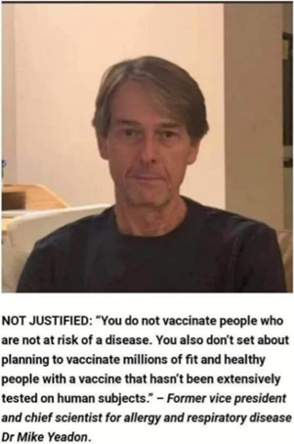

**Everyday experiences of people who have received the vaccine**

*'I've also joined a few groups on Facebook where people share their experiences of the vaccine. I like this group as you get to hear about people's experiences from the vaccine. The contributors are usually from different parts of the world' [Sic]*

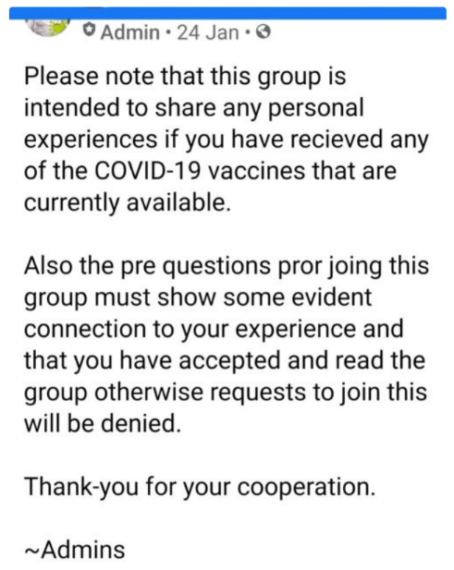

## Everyday people sharing their views and experiences

**People suffering having taken the vaccine**

*'Within 3 days problems with this women's face and this is very scary' [Sic]*

Video on YouTube.

[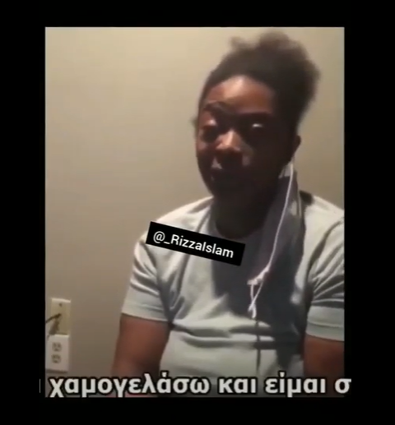](https://www.youtube.com/watch?v=R9qs10Pdx_4)

**Everyday people standing against the vaccine**

*'Another terrifying video about Covid-19 vaccine, I got chills when I heard the word poison. To be honest, seeing this video led me to believe that taking the vaccine could be a mistake.' [Sic]*

Video of a man stood outside a vaccine centre in Birmingham saying the vaccine is not permissible for Muslims to take and shouting at people not to take it.



## Official sources and mainstream news

**Official information sources, for example BMJ, NHS, Gov.uk**

*'A screen shot taken today from the gov.uk website I was particularly interested in the 'duration of protection' paragraph. So they are pushing and scaring people into taking a vaccine where really the so called protective attributes could wear off the next day and really what was the point in the first place.' [Sic]*

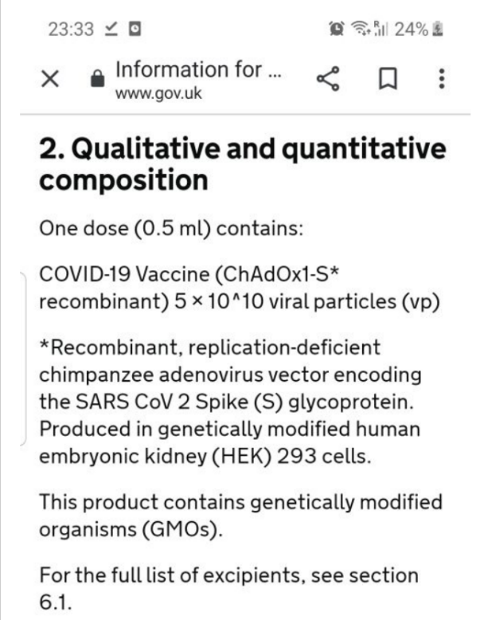

**Mainstream news**

*'Every day is something new about the vaccine whether it's supply shortage, clotting risks in the Astra Zeneca one, now same with the Johnson and Johnson. Fertility concerns cropping up again.' [Sic]*

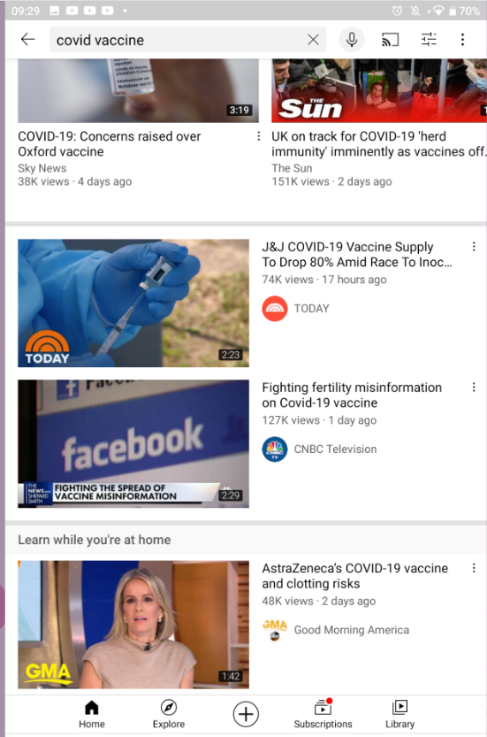

## Humour and expressions of where participants stand

**Humour about the vaccine**

*‘I saw this meme and found it quite funny as people will start taking the vaccine, zoom calls will start to decline as people will be going back to work/studying.’ [Sic]*

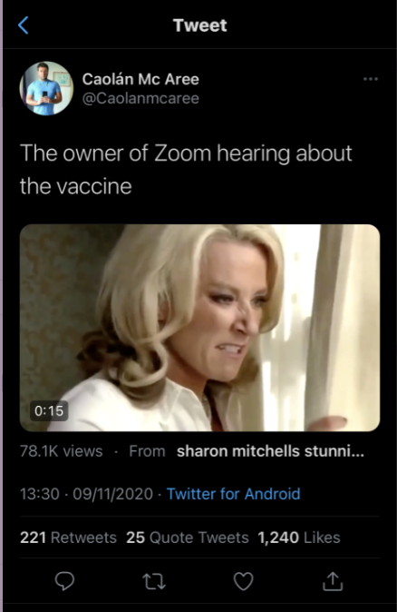

*‘It is kind of true because they are the ones to approve them but we need to feel safe about it’ [Sic]*

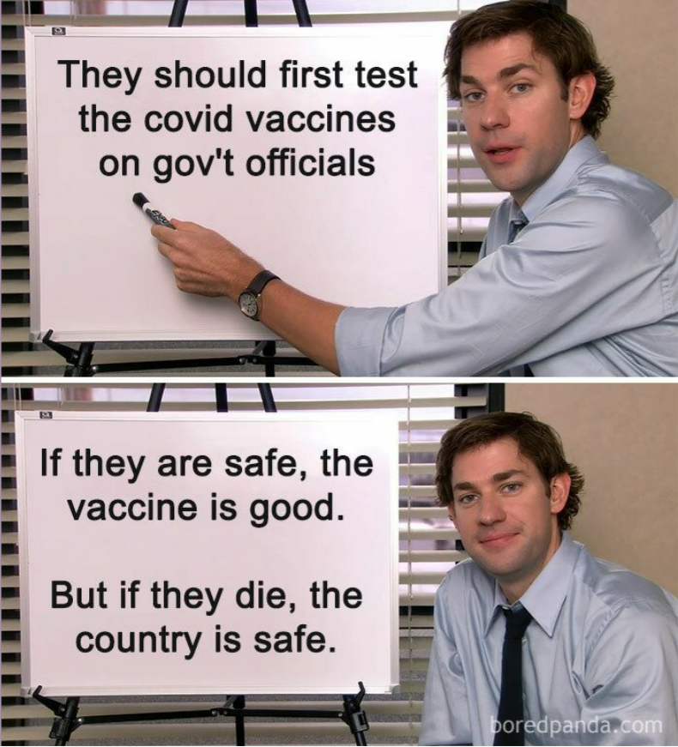

*‘A typical humorous post I like and would see and post on my social media. Subtlety giving my no covid vax status.’ [Sic]*

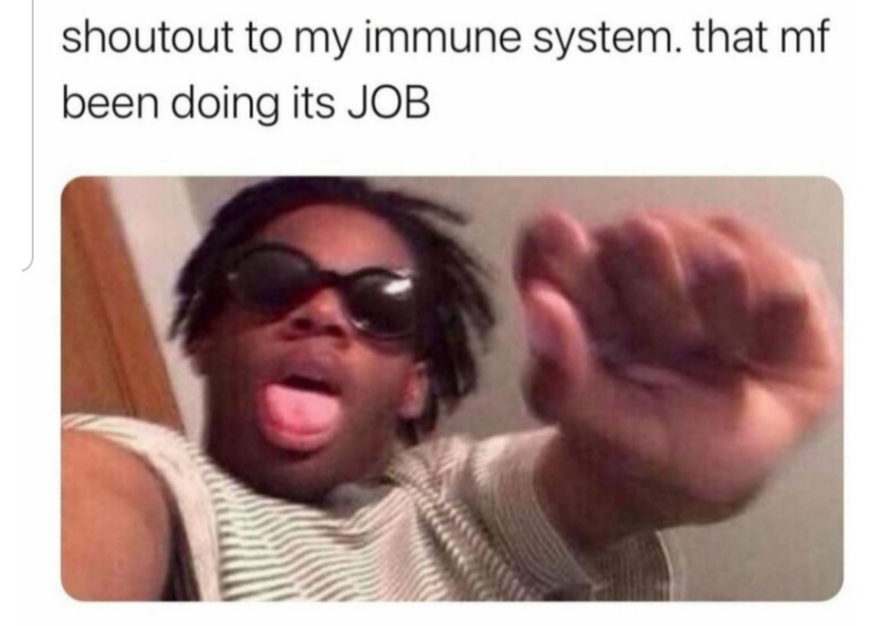

## Official campaigns that don’t provide enough information, or fail to address ambiguity surrounding the impact of the vaccine, can be problematic and lead to greater suspicion

An example of official communications shared by the research team for participants to respond to was a film produced by Public Health England (18).

The biggest issue participants had with this video was that, despite the key message being about the vaccine being safe, there was no recognition of unknown outcomes relating to potential long-term impacts.

The doctor featured in the video says there is no concern about the impact **yet**, which was noted by many participants who were left with a feeling of uncertainty.

This highlights a tension in that ambiguity, when not directly addressed, can result in greater suspicion.

Many participants expressed that if ambiguity was openly recognised and discussed by official sources, they would feel as though they were being treated with respect rather than simply feeling pressurised to take the vaccine.

*‘Seems a bit more serious and would instantly grab my attention as it is from public health however again its just someone speaking. I want to see evidence, an informative science-based video about the vaccine what it contains what it does when entering your body, studies about fertility links is what I am after.’ [Sic]*

## Participants called for more detailed information from official sources and for ambiguity to be addressed directly

*‘ok, public health. She isn’t even sure. Still no answers- smoke and mirrors! Yes, I do respect the NHS but one of her sentences ended with ‘yet’- so no one knows and yet we are expected to be guinea pigs? Nope…I think awww that’s really nice that people are coming together to try and convince people to take the vaccine. I then feel very frustrated due to the lack of info. I am not anti vaccines, I am anti make your own story up depending on what is on the governments agenda!’ [Sic]*

## With so much content to digest, participants can feel overwhelmed by the amount of conflicting information and do not have support to navigate it

Participants felt the amount of differing information they saw about the vaccine – from memes through to official messaging - was often conflicting and could be confusing. They recognised the need to evaluate information and its legitimacy, but felt they were not always fully equipped with the necessary skills to do so effectively.

*‘I try to consume a lot, and I have friends who don't agree with the mainstream media and send me links, and I read it and I find myself somewhere in between. I know however that I don't have the right skillset so I can't trust my own conclusions.’*

*‘I just feel, especially the media, give out a lot of conflicting information which can confuse people. I feel sometimes you don’t know what to believe and it causes confusion.’*

*‘It's a rabbit hole when you try and do your own research.’*

*‘I think we all as individuals have to make our own decisions based on our interpretation of what is true.’*

## Medical professionals are trusted sources on the vaccine, particularly if participants have an existing relationship with them, and they were not seen as being linked to Government messaging

When participants were asked who they trust to answer their questions about the vaccine, the most common answer on the online platform was members of the scientific and medical community.

However, it was clear from existing published data on the disparities in vaccine uptake that messaging from these sources thus far has not cut through to the participants who feel more hesitant or lack the most confidence. When we explored the issue of trust further in discussion groups, we were able to unpick initial responses in more detail.

In discussions, participants said there was a difference in how they would receive a message on the vaccine depending on proximity of the messenger to them. For example, their own GP was viewed as more invested in their health than a healthcare worker with whom they had no personal relationship. Therefore, the motive behind messaging from the latter was more likely to be questioned.

The Government was felt to be the least trustworthy source of information on the vaccine and some participants described this impacting the levels of trust they had in the NHS, adding it had become hard to distinguish between the two.

*‘At least I have a personal relationship with my GP, someone I can speak to one to one. Their aims are obviously our health - different from politicians’*

*‘I do trust the NHS, but at the moment it's hard to see who is saying what , there is a lot of crossover with central government.’*

## Local networks are a trusted source of information, though more so if they have some knowledge or experience to qualify their opinions

Many participants described friends, family and their religious leaders as those they trust the most in general terms.

However, while they trusted their opinions and were happy to discuss their thoughts around the vaccine, unless these networks had either medical or religious knowledge beyond that of the participant, there was an underlying recognition that they too might not have all the answers. For example, while an Imam might be trusted to say the vaccine is considered halal, participants wouldn’t expect them to accurately advise on the medical impact of taking the vaccine.

The level of trust among participants in their local GP as opposed to a generic healthcare professional also applied to religious leaders; participants trusted their own local religious leader more than one with whom they had no personal relationship.

As with central Government, local politicians were viewed as completely untrustworthy and not seen as a source from which they could attain reliable information about the vaccine.

*‘My family and community, I take advice from. It's a cultural thing. If I have a headache they're the people I ask first. Even with the vaccination, I take a lot of advice from my Caliph, my community is a go to place.’*

*‘I’d talk to people I personally trust who know more than me.’*

*‘Anyone who has an agenda I’d be cautious of. In terms of influence, I think family or friends would have the biggest hold over me.’*

**Circle of trust**

Black and Asian celebrities

Medical academics

Front line NHS staff

Scientists

Prime Minister or local MP

Public health officials

A religious leader

My local community leader

My local religious leader

My family GP

My friends and family

Me – **maximum trust**

## How participants would manage the vaccine roll-out

In the final task on the online platform, participants were asked to describe how they would manage the vaccine roll-out if they were in charge. The most frequent answers provided were:

* Localising the approach by engaging communities, targeting specific gaps, and getting local, trusted community members involved.
* Increasing the amount of information publicly available on the vaccine, including more transparency about potential impacts.
* Consulting experts such as scientists and ensuring their advice is embraced and actioned.

### Localise the approach

* *‘I would look at the gaps in communities and areas then make a targeted program for them’ [Sic]*
* *‘More effort to engage communities’ [Sic]*
* *‘Ask for help from GP's, educators, social workers, community leaders, civil service and local councils (as opposed to central government).’ [Sic]*

### Increase information on the vaccine

* *‘Establish what the vaccine actually does? Identify risks and look at mitigating risks.’ [Sic]*
* *‘Be more transparent about side effects’ [Sic]*
* *‘explain the long term implications on the younger population’ [Sic]*

### Consult Experts

* *‘I'd follow scientific advice, something this government has not done despite claims to the contrary. For example (and this is one of many), if one knows that, whilst children are less likely to be symptomatic, they are one of the biggest spreaders, why would you leave teachers out of the first phases but still open schools?’ [Sic]*
* *‘Look at the information presented by other professors, scientists and virologists’ [Sic]*

## Building on the Healthwatch England survey hypotheses

As highlighted at the start of this report, one intention for the research was to build upon the hypotheses Healthwatch England posed from their survey results. The below text speaks to these directly.

### Practical barriers

These did not come up as a big issue for research participants in this study. Some did mention concerns around transmission risks when attending GP surgeries or vaccine centres.

### Transport barriers

Again, this was not a big factor for this cohort of participants. Because most Black and Asian people in England live in cities, many participants were based in large urban areas so were able to access vaccine centres with relative ease.

### Fake news/misinformation

Participants received information about the vaccine from a mixture of sources, and described a lot of conflicting messages, often leaving them with more questions.

Problems of misinformation were felt to be especially acute for those who did not have English as their first language.

### Impact of taking the vaccine

In discussion groups, the short-term effects of the vaccine was a lesser issue than anticipated based on hypotheses from the Healthwatch England survey. However, short-terms impacts were often linked to not knowing fully what the vaccine contained, how it works, and its long-term impacts.

### Deeper cultural mistrust

As previously highlighted, this was felt to be an issue for participants, many of whom did not trust the intentions of the government and pharmaceutical companies. This stemmed from a sense that the government, NHS and vaccine manufacturers have not been honest and upfront about the uncertainty of any long-term health implications of the vaccine.

Religious issues did not come up as much as anticipated in relation to mistrust. What was expressed was more to do with the underlying issues of transparency from the government, and whether there is something to hide around the vaccine roll-out.

In discussion groups, some participants spoke with concern about the ethics of selling the vaccine to other countries in Africa and Asia.

*'After this, developing countries, including Africa, will be indebted to the British government for hundreds of years to come which will add to the power imbalance.*'

### Impact of health and care staff:

The imagery of medical staff not taking the vaccine was powerful for participants, who shared numerous examples of this on the online discussion board. This was linked to the power of messages coming from people who have tangible experience with the vaccine.

### Generational differences:

Some generational differences were highlighted through this research. While some older participants displayed deep mistrust of institutions, they were more likely to have had, or be willing to have, the vaccine. Meanwhile, younger participants were more likely to share extreme views about the intentions behind the vaccine roll-out being sinister and/or conspiratorial.

### Community/peer interaction:

There were some findings to support that family, friends and peers influence the behaviours and attitudes of those close to them. However, participants expressed that those in their network with specific knowledge (either through tangible experience of the vaccine such as having worked in frontline healthcare positions, had taken it themselves, or had deeper religious knowledge) were more likely to influence them when it came to the vaccine.

Overall, this research supported many of the hypotheses from the Healthwatch England survey. The main differences related to these research participants placing less emphasis on practical and transport barriers. This may link to the make-up of the sample, the majority of whom were based in large metropolitan areas.

#### Key action points and top tips

## Key actions to increase trustworthiness in public health messaging

Findings from this research highlight four key elements that could contribute to increasing trust in public health messaging about the Covid-19 vaccine among hesitant Black and Asian people – **agency, independence, transparency** and **experience.**

**1.** **Agency: *People’s sense of agency is pivotal to their decision making.***

Removing an individual’s agency from their decision-making may result in them seeking out alternate information. This is currently used as a technique by those spreading misinformation - encouraging people to do their own research and make up their own mind.

Participants wanted authorities to present the public with information with which they can make their own decisions.

**2. Independence: *The independence of institutions, and those for whom they speak, is crucial in building trust.***

There is very limited trust in the Government, but participants, largely, trust the NHS. However, that trust wanes when they feel the NHS is being used as a Government tool or mouthpiece.

In this regard, participants prefer listening to doctors, scientists, or experts who are somewhat removed from the vaccine roll-out.

There was also general distrust of those who have any possibility of standing to gain commercially from the roll-out, such as pharmaceutical companies.

**3. Transparency: *The more transparent an organisation or information source, the more trustworthy.***

Regardless of whether they would access the information, participants wanted to know that all the information on the vaccine is public and accessible. The more organisations can make such information available or sign-post to it, the better.

This is reflected in participants’ desire for a range of sources of information that can be verified against one another.

**4. Experience: *The more real-world experience that an individual has with Covid-19/vaccines, the more reliable they are as a source of information.***

Participants cited everyday-people sharing experiences of having had Covid-19 and/or the vaccine as trustworthy.

Participants also said they trust frontline healthcare workers to discuss the Covid-19 vaccine, whereas they have less trust in those very senior in organisations like the NHS, since they have less tangible experience.

They don’t necessarily trust faith leaders or celebrities on the issue of vaccines for the same reasons, and feel those who are local to the individual, such as their own GP, are more credible.

## Top tips: tone and format checklist

When creating Covid-19 vaccine communications for Black and Asian people who are hesitant or lack confidence, the following findings can act as a checklist in relation to tone and format.

1. It is fundamental for any communications directed at Black and Asian people to recognise that they are not one homogenous group.
2. Acknowledge that some ambiguity exists relating to the potential long-term impacts of the Covid-19 vaccine.
3. Recognise the legitimacy in some level of scepticism based on deep-rooted mistrust in institutions experienced by Black and Asian people.
4. Create content that has a conversational format providing as much information as possible. Avoid overly-simplistic approaches to communication.
5. Ensure messages are practical and accessible (e.g. available in multiple languages).
6. Ensure the tone speaks *to* the audience as opposed to *at* them.  Don't share strong directional messages without providing more context.

*‘They should be honest and tell the truth. Let people make an informed decision and choice. Stop trying to push people into a corner to take the vaccine. Give them the info, be open and honest, if you don’t have the info at least say that you don’t and say the steps you’re taking to ensure there is sufficient info. With any vaccine or medicine there are always risks, I don’t think any of us are unaware of that, but I feel it needs to be conveyed consistently. Its been inconsistent so far and its been unhelpful as it damages trust. And also when it comes to BAME, don’t insult our intelligence because were from BAME and think you can go and get whoever to influence you. What you’re saying is we cant think for ourselves, we don’t want the scientific info and will just be swayed by the celebs. Don’t underestimate our intelligence, give us the info and involve us.’ [Sic]*

#### Appendices

## Participant age and ethnicity

## Participant gender and religion or belief

## Participants SEG and vaccine attitudes

## Example of recruitment materials shared on social media

## 

**References**

[(1) Getting to vaccine centres more of a barrier for Black communities | Healthwatch](https://www.healthwatch.co.uk/news/2021-02-22/getting-vaccine-centres-more-barrier-black-communities)

[(2) https://www.lbc.co.uk/radio/presenters/nick-ferrari/caller-vaccine-fear-government-control-population/](https://www.lbc.co.uk/radio/presenters/nick-ferrari/caller-vaccine-fear-government-control-population/)

[(3) https://metro.co.uk/2020/12/10/anti-vaxxers-called-stupid-and-selfish-as-1-in-5-unlikely-to-get-vaccine-13730541/](https://metro.co.uk/2020/12/10/anti-vaxxers-called-stupid-and-selfish-as-1-in-5-unlikely-to-get-vaccine-13730541/)

[(4) https://metro.co.uk/video/queen-blasts-refuse-vaccine-didnt-hurt-selfish-2363554/](https://metro.co.uk/video/queen-blasts-refuse-vaccine-didnt-hurt-selfish-2363554/)

[(5) https://www.gov.uk/government/publications/the-report-of-the-commission-on-race-and-ethnic-disparities](https://raceequalityfoundation.org.uk/wp-content/uploads/2018/02/Health-Briefing-39-_Final.pdf)

[(6) https://www.bbc.co.uk/news/world-us-canada-56320101](https://raceequalityfoundation.org.uk/wp-content/uploads/2018/02/Health-Briefing-39-_Final.pdf)

[(7) https://www.theguardian.com/uk-news/2021/apr/21/george-floyd-case-reignites-calls-to-tackle-racial-injustice-in-uk-policing](https://raceequalityfoundation.org.uk/wp-content/uploads/2018/02/Health-Briefing-39-_Final.pdf)

[(8) https://www.theguardian.com/uk-news/2020/sep/03/hostile-environment-has-fostered-racism-and-caused-poverty-report-finds](https://raceequalityfoundation.org.uk/wp-content/uploads/2018/02/Health-Briefing-39-_Final.pdf)

[(9) https://www.theguardian.com/uk-news/2021/may/07/inquest-to-be-held-into-covid-death-of-rail-worker-allegedly-spat-at-by-customer](https://raceequalityfoundation.org.uk/wp-content/uploads/2018/02/Health-Briefing-39-_Final.pdf)

[(10) https://www.youtube.com/watch?v=A2tGEVwUuKw](https://raceequalityfoundation.org.uk/wp-content/uploads/2018/02/Health-Briefing-39-_Final.pdf)

[(11) Beyond the Snowy White Peaks of the NHS](https://raceequalityfoundation.org.uk/wp-content/uploads/2018/02/Health-Briefing-39-_Final.pdf), Kline, 2015

(12) Under-representation of minority ethnic groups in research – call for action, Redwood & Gill, 2013

(13) The health of people from ethnic minority groups in England, Raleigh, Holmes, 2021

[(14)Edelman Trust Barometer](https://www.edelman.co.uk/sites/g/files/aatuss301/files/2021-02/2021%20Edelman%20Trust%20Barometer%20-%20UK%20Media%20Deck.pdf), 2021

[(15) Black leaders fear racist past feeds mistrust in vaccine](https://www.bbc.co.uk/news/health-56813982) BBC, May 2021

[(16) Ethnic differences in SARS-CoV-2 vaccine hesitancy in United Kingdom healthcare workers: Results from the UK-REACH prospective nationwide cohort study](https://www.medrxiv.org/content/10.1101/2021.04.26.21255788v1), Woolf et al, 2021

(17) <https://www.theguardian.com/world/2021/feb/18/bame-groups-urged-to-have-covid-vaccine-in-uk-tv-ad-campaign>

(18) <https://www.youtube.com/watch?v=3Ixp2mD6gZg>

## Thank you

For further information contact

**Healthwatch:** [research@healthwatch.co.uk](mailto:research@healthwatch.co.uk)

**Traverse:** [Jessie.Cunnett@traverse.ltd](mailto:Jessie.Cunnett@traverse.ltd)