Charlton Park Care Home Follow-up Report
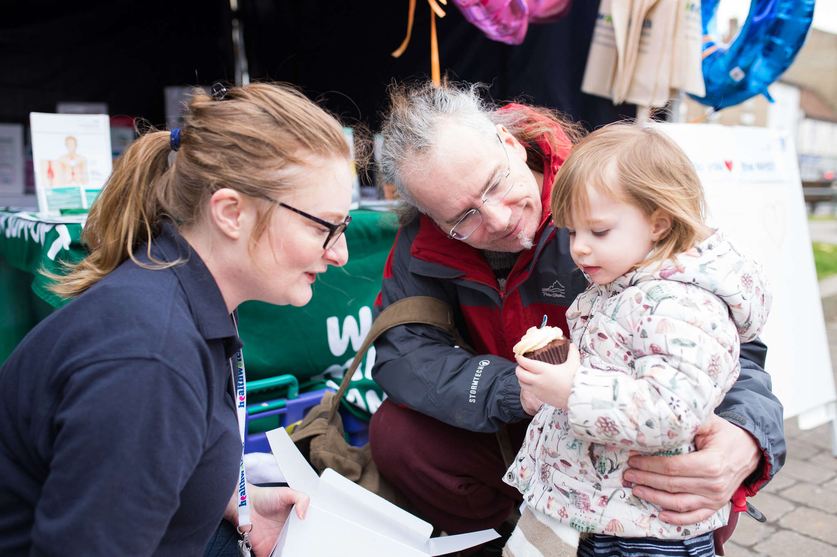
March 2023

Contents
Contents 1
Acknowledgements 2
Recommendations 3
Contact us 8

Enter and view
Healthwatch has a legal power to visit health and social care services and see them in action. Enter & View is not an inspection; we do not look at care plans, medicines management, or clinical issues. The Care Quality Commission (CQC)look at the clinical aspects of a service. We offer a lay perspective. We ask residents, families, and carers, what they think of the service they receive. Our focus is on whether a service works for the people using it.

Acknowledgements
We would like to thank the Deputy Manager, staff and residents of Charlton Park Care Home for their time and assistance.

Recommendations

Charlton Park Care Home Enter and View Report - March 2022
Healthwatch Greenwich visited Charlton Park Care Home and offered the following recommendations:
- Promote communal dining for residents.
- Include culturally inclusive food for residents, particularly those with dementia.
- Increase dementia-friendly activities.
- Involve the community in developing activities for residents.
- Review storage practice and ensure facilities are accessible for resident’s use.
- Reinstate Relatives Meetings.
- Consider adding seating areas in corridors.
- Renovate furniture and décor and conduct maintenance repairs.
- Enhance garden and garden furniture for residents enjoyment.
- Keep reception area tidy.
- Display complaint procedure information in reception and notice boards.

Follow up on recommendations.
Our authorised representative conducted an unannounced visit in March 2023 to follow up on the recommendations. The Care Home’s Deputy Manager, David Sillah provided information and evidence.

1.Encourage residents to eat in social settings, with others, in communal dining areas.
Action Taken: Residents are encouraged to eat in communal spaces but may choose to eat in their individual rooms.

2.Culturally inclusive food to be included in the menu, in particular for residents with dementia that may lack the capacity to request it.
Action Taken: The menu does include culturally inclusive food options. While residents and relatives have the ability to request ethnic foods, the current menus provided do not include any pictures or options for these types of foods.

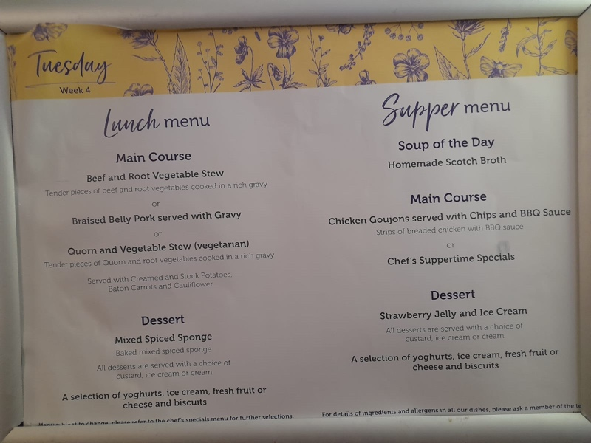
The Lunch and Supper Menu for Charlton Park Care Home on March 7th, 2023.

3.Increase dementia-friendly activities.
Action Taken: Charlton Park uses Oomph! and Magic Moments platforms for residents with dementia and incorporates sensory activities as noted in activity reports.
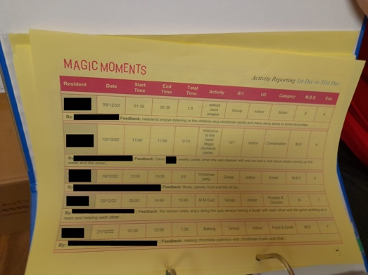

4.Involve the community in developing activities for residents.
Action Taken: The home has occasional visits from local primary schools.

5.Review storage practice and ensure facilities are accessible for resident’s use.
Action Taken: The hairdressing salon is now back in use and the care home is free of clutter.

6.Reinstate Relatives Meetings.
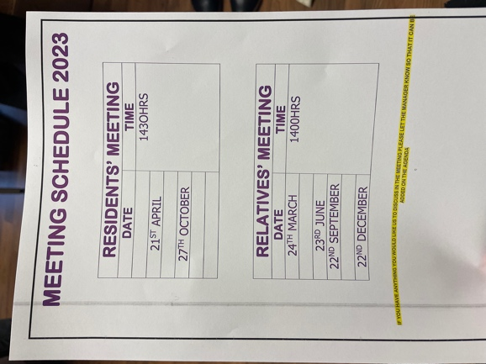
Action Taken: Relatives Meetings have been re-established. The first relatives meeting of 2023 will take place in March 2023 (last meeting took place eight months previously in July 2022).

7.Consider opportunities to introduce additional seating areas in the corridors.
Action Taken: Additional seating has been introduced.

8.Renovate furniture and décor and conduct maintenance repairs.
Action Taken: New chairs and tables for lounge areas have been purchased. Furniture and decoration will be updated throughout the care home.
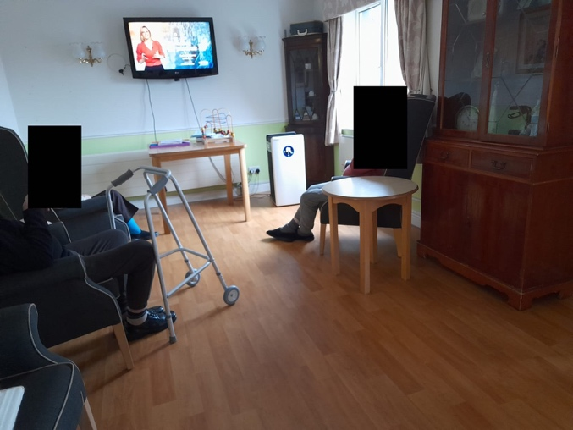
There are new chairs and tables in the upstairs lounge area.

9. Enhance garden and garden furniture for residents enjoyment.
Action Taken: Plans are underway to put in new plants and raised garden beds during the spring.
Charlton Park Care Home gardens

10. Keep reception area tidy.
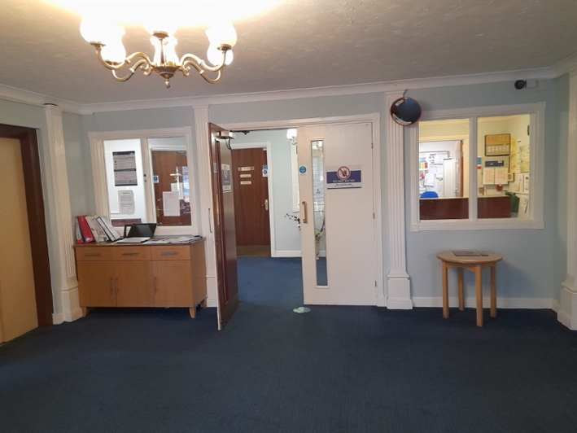
Action Taken: Reception area is clean and tidy.
Reception area is clean and free of clutter.
11. Display complaint procedure information in reception and notice boards.
Action Taken: In the reception area, a poster detailing the procedures for submitting complaints is visible. Adjacent to the visitor sign-in area, there is a box designated for collecting comments and suggestions.
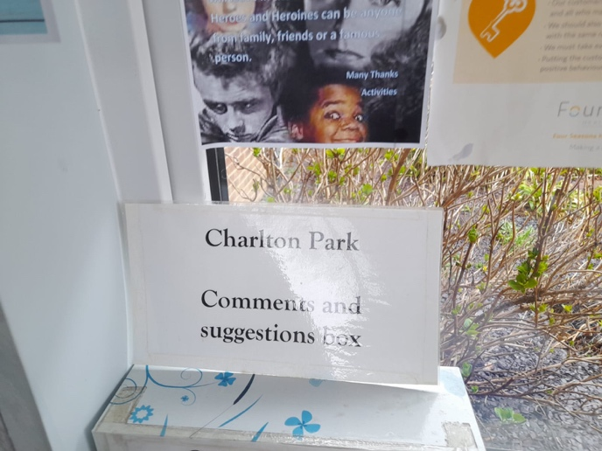
. Right: Charlton Park comments and suggestions box.

If you require this report in an alternative format, please contact us.

We confirm that we are using the Healthwatch Trademark (which covers the logo and Healthwatch brand) when undertaking work on our statutory activities as covered by the licence agreement.

© Copyright Healthwatch Greenwich 2020
Gunnery House
Gunnery Terrace
Woolwich
London
SE18 6SW

​www.healthwatchgreenwich.co.uk
t: 020 8301 8340
e: ​info@healthwatchgreenwich.co.uk
@HWGreenwich
Facebook.com/Healthwatchgreenwich

