Cullum Welch Court Care Home
April 2023

Contents
Contents 1
Enter and View 2
Acknowledgements 2
Recommendations 2022 2
Follow-up on recommendations 2023………………………………………………….3
Contact Us 5

Enter and View
Healthwatch has a legal power to visit health and social care services and see them in action. Enter & View is not an inspection; we do not look at care plans, medicines management, or clinical issues. The Care Quality Commission (CQC)look at the clinical aspects of a service. We offer a lay perspective. We ask residents, families, and carers, what they think of the service they receive. Our focus is on whether a service works for the people using it.

Acknowledgements
We would like to thank the lead nurse, staff, residents and relatives of Cullum Welch Court Care Home for their time and assistance.

Recommendations - 2022
In April 2022 Healthwatch Greenwich visited Cullum Welch Court Care Home and provided the following recommendations:

- Establish regular relatives/residents’ meetings.
- Review provision of activities and evaluate residents and relatives’ satisfaction with current model.
- Sensory Room to be used to support the wellbeing of residents living with dementia.

- Enhance security with a member of staff receiving guests on entry.

- Display complaints information in the reception area, within each unit, and on the website.

- Offer more frequent baths or showers to residents.

Follow up on recommendations - 2023
We re-visited in 2023 to follow up on our recommendations.

1: Establish regular relatives/residents’ meetings

Relatives’ meetings take place once a month.

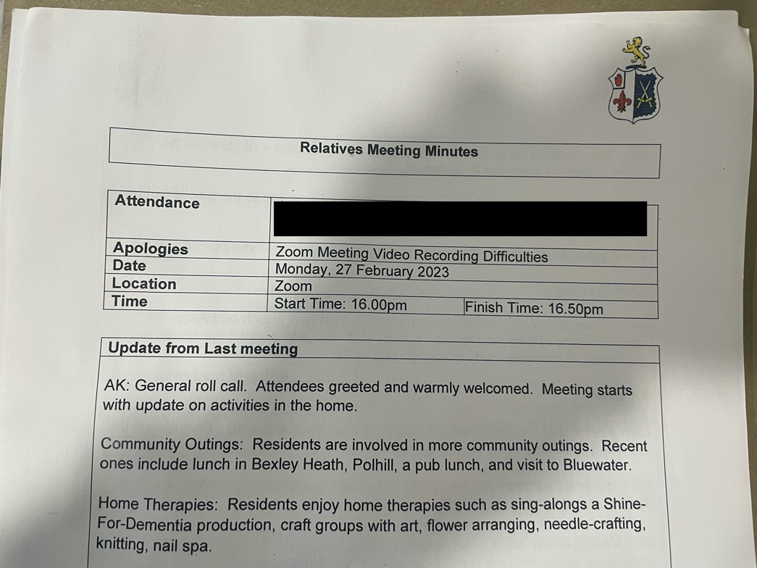
Relatives meeting minutes on February 27th.
2: Review provision of activities and evaluate residents and relatives’ satisfaction with current model.
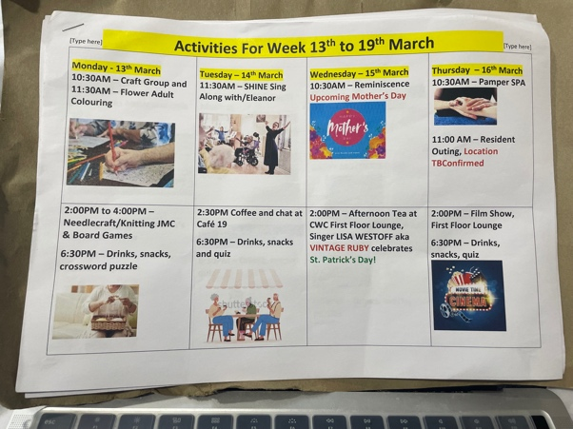
A carer has been appointed to coordinate activities. Activities include SHINE sing along, crafts, puzzles, and theme parties. Every Wednesday there is afternoon tea for residents.

3: Sensory Room to be used to support the wellbeing of residents living with dementia.
The sensory room is currently used as a multipurpose seating area for relative and staff meetings.

4: Improve security with a member of staff receiving guests on entry.
The building’s security has been improved. The entry door is locked and guests are given entry by a staff member.

5: Display complaints information in the reception area, within each unit, and on the website.
No complaint information is displayed in the reception area, within each unit or on the website.

6: Offer more frequent baths or showers to residents.
Residents without capacity to do so themselves receive daily bed baths. Residents can also request a bath or shower.
Gunnery House
9-11 Gunnery Terrace
Woolwich Arsenal
SE19 6SW

www.healthwatchgreenwich.co.uk
t: 0208 301 8340
e: info@healthwatchgreenwich.co.uk
@HWGreenwich
Facebook.com/Healthwatchgreenwich

