Riverlee Residential and Nursing Home
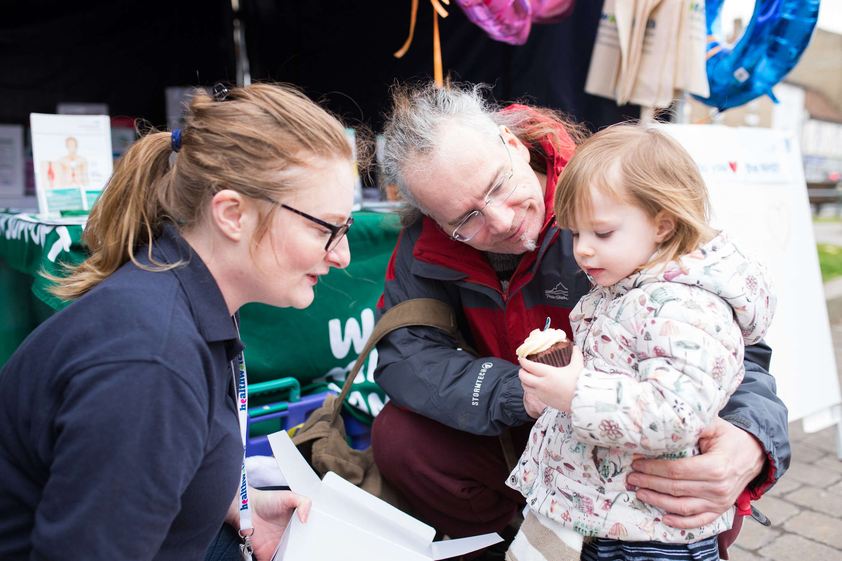
February 2023

Contents
Contents 1
Enter and View 2
Acknowledgements 2
Recommendations 2022 2
Follow-up on recommendations 2023………………………………………………….3
Contact Us 4

Enter and View
Healthwatch has a legal power to visit health and social care services and see them in action. Enter & View is not an inspection; we do not look at care plans, medicines management, or clinical issues. The Care Quality Commission (CQC)look at the clinical aspects of a service. We offer a lay perspective. We ask residents, families, and carers, what they think of the service they receive. Our focus is on whether a service works for the people using it.

Acknowledgements
We would like to thank the manager Cecillia Agadzi, staff, residents and relatives of Riverlee Residential and Nursing Home for their time and assistance.

Recommendations - 2022
In April 2022 Healthwatch Greenwich visited Riverlee Residential and Nursing Home and made the following recommendations:

- Display photographs and names of key staff members in the reception area.

- Improve personal hygiene by offering more baths or/and shower and ensure that clothing is clean.

- Review health and safety practice and ensure communal bathroom facilities are safe for residents’ use.

- Greater engagement with residents in the planning of activities.

- Ensure all facilities are accessible for residents’ use.

- Resume regular visits to places of worship and visits from religious leaders for residents who would like to practice their religion.

- Regular routine NHS dental care visits.

Follow up on recommendations - 2023
We re-visited in 2023 to follow up on our recommendations.

1: Display photographs and names of key staff members in the reception area.

A board with names and photographs of key staff members is displayed in the reception area.
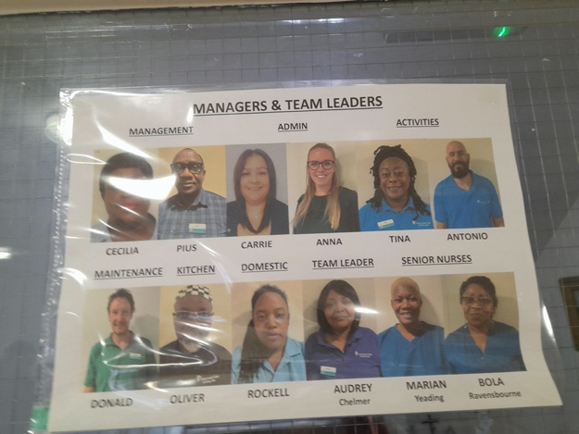
Staff names and pictures
2: Improve personal hygiene by offering more baths or/and showers and ensure that clothing is clean.
During our follow-up visit all residents appeared clean and happy.

3: Review health and safety practice and ensure communal bathroom facilities are safe for residents’ use.
All bathrooms are safe for residents’ use.

4: Greater engagement with residents in the planning of activities.
Residents are encouraged to give feedback and suggestions about activities at monthly meetings.

5: Ensure facilities are accessible for residents’ use.
The sensory room has been converted to a visitor’s room and is accessible for residents’ use.

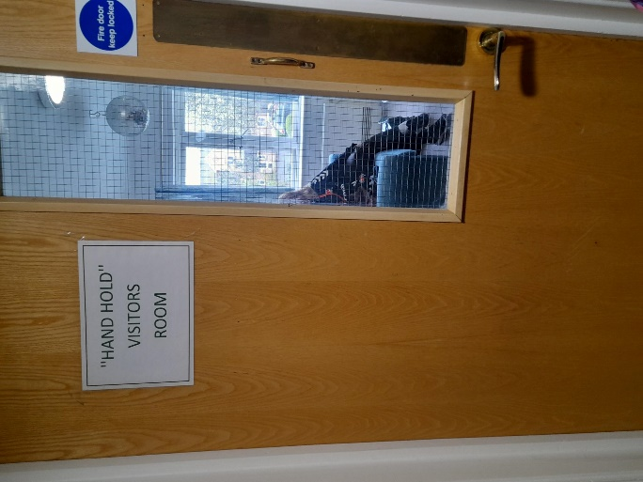

6: Resume regular visits to places of worship and visits from religious leaders for residents who would like to practice their religion.
New Wine Church visits once a month. Visits from a Seven Day Adventist Church are being planned.

7: Regular routine NHS dental care visits.
A dentist visits twice a year. Referrals for further dental care are sent to Bromley Healthcare.

Contact Us
If you require this report in an alternative format, please contact us.

Gunnery House
9-11 Gunnery Terrace
Woolwich Arsenal
SE19 6SW

www.healthwatchgreenwich.co.uk
t: 0208 301 8340
e: info@healthwatchgreenwich.co.uk
@HWGreenwich
Facebook.com/Healthwatchgreenwich

